If we create a VPC manually without wizard, then the we get an empty VPC without subnets, route tables and internet gateway

But if we create by selecting anyone of the first two options in wizard, then these things get created automatically

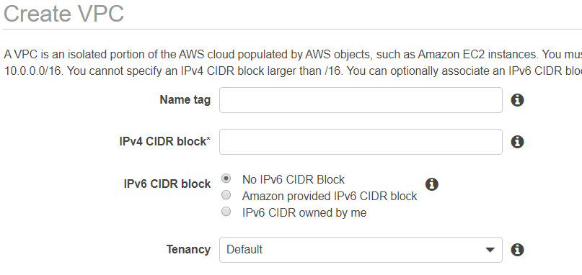

**Creation with wizard:**

* We can have VPC with only public subnet. That is one choice

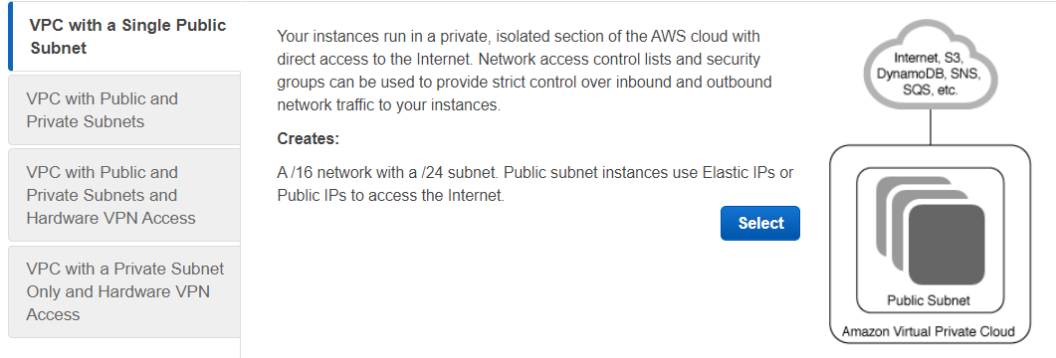

* Or we can have public and private subnets. whereas the resources in private subnet having only private IPs
* Many customers prefer to have this one

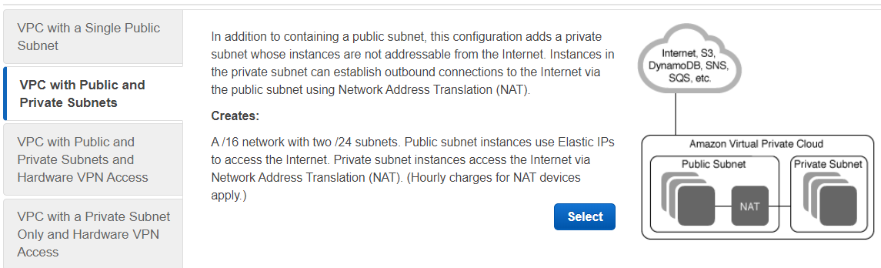

* Web servers route the traffic to application servers
* Another type is to have public and private with VPC configuration
* VPC is used for secure transferring the data in encrypted format

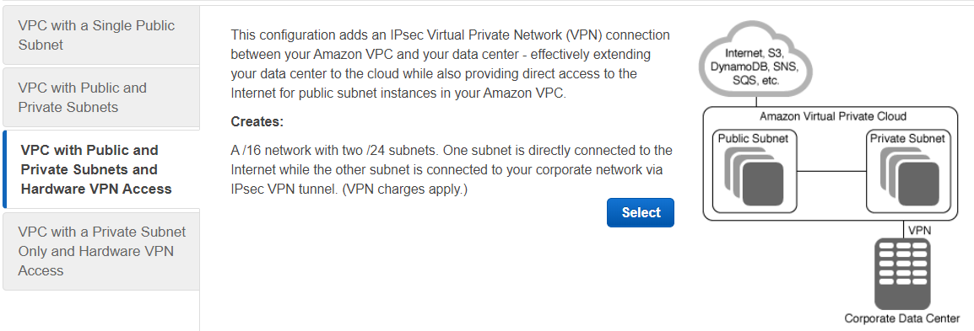

* We can have entire private cloud where in which we can have private subnet

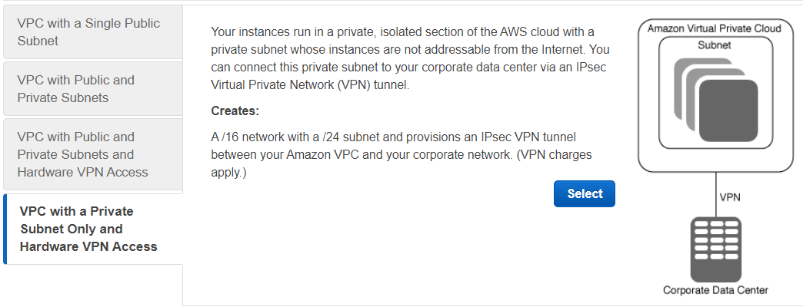

* CIDR stands for Classless Inter Domain Range
* While creating VPC, we better give VPC name along with CIDR block. That would help us

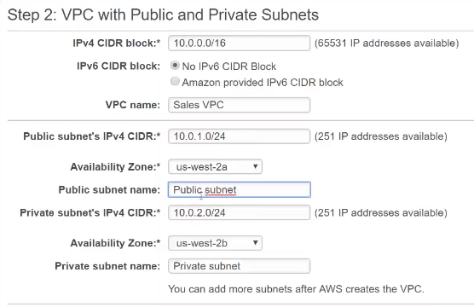

* we need to give the CIDR range and then we need to create the subnets in between that range only
* we can divide the same IP as below as well

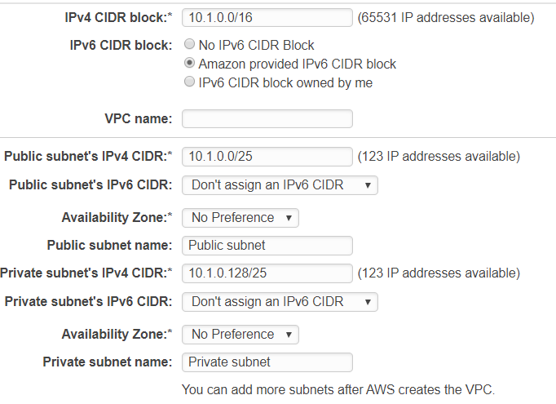

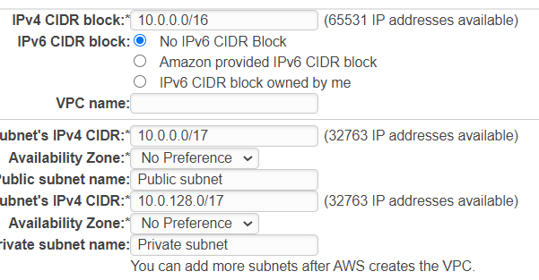

We can divide and create the subnets in groups as we want using the above method

The CIDR block must be in between /16 and /28 as below

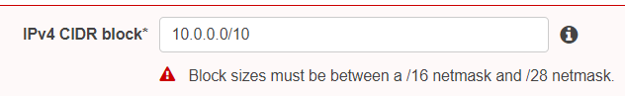

We need to give the elastic IP for NAT gateway

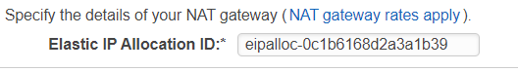

* We can create the endpoint while creating VPC itself as below or we can also create it later and add to the VPC

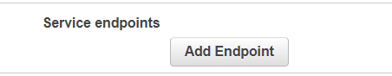

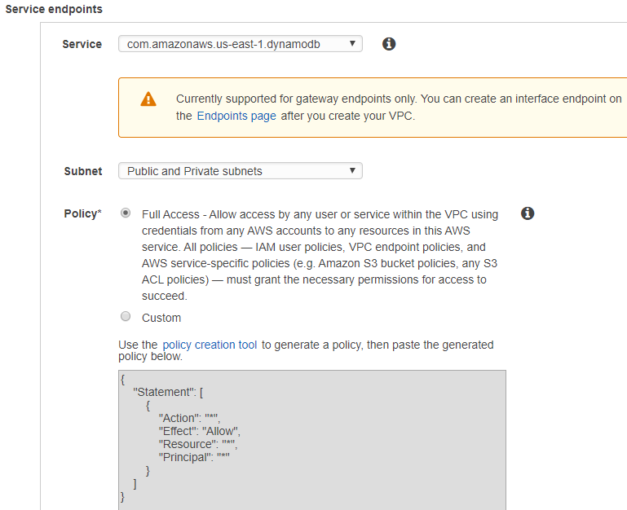

* We can create VPC with public and private as above

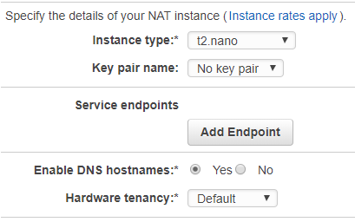

* Hardware tenancy is for where we want to launch our VPC, we can leave it default if we want to use shared hardware
* If we want dedicated hardware, then we need to have dedicated option selected which is more expensive
* We can enable the DNS hostnames so that the servers will get DNS hostnames when we launch inside VPC. This option is default enabled when we create VPC from vizard. But if we create custom VPC. We need to enable it manually
* Even after creation VPC, we can go to actions of VPC and edit DNS hostnames to enable or disable it

**Create an instance in custom VPC:**

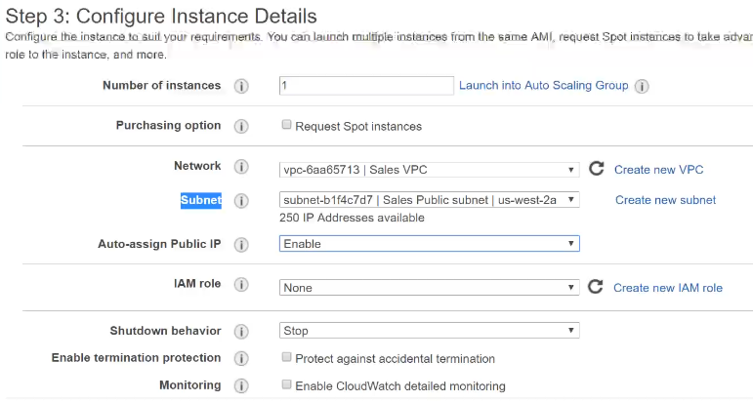

* While creating an instance, we can assign the VPC as above
* We should have at least one subnet in VPC
* When we use wizard, it creates internet gateway automatically. When we create VPC manually, we need to create IGW manually.

**We will get everything as in default gateway, when we create a VPC using wizard**

**DNS hostnames:**

* We need to select this option while creating the VPCs. So that the instances will get DNS names.

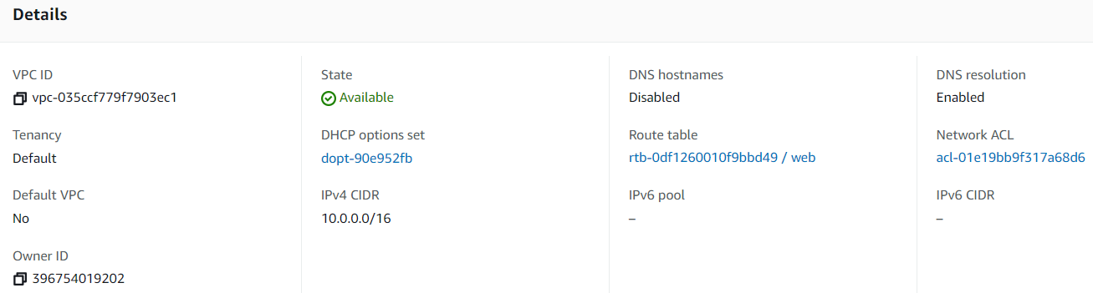

* If not, we can also enable it later.

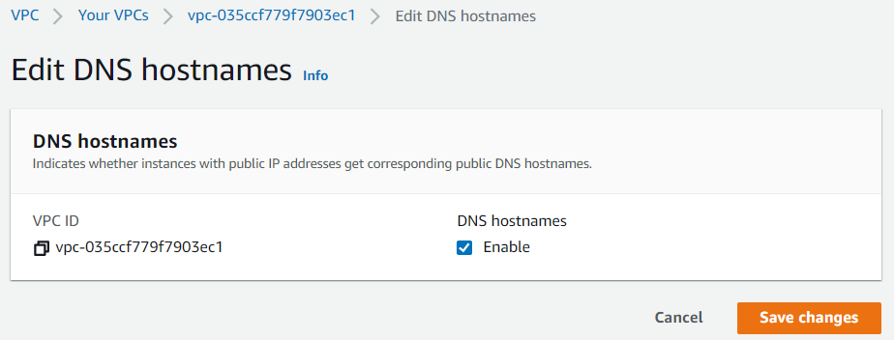

**Amazon reserves 5 IPs in each subnet:**

